Q1)

#include <iostream>

using namespace std;

class Shape {

public:

void area() {

cout << "This is the area of the shape." << endl;

}

void area(int length, int width) {

cout << "Area of Rectangle: " << length \* width << endl;

}

};

class Circle : public Shape {

public:

void area(int radius) {

cout << "Area of Circle: " << 3.14 \* radius \* radius << endl;

}

};

int main() {

Shape s;

Circle c;

s.area();

s.area(5, 6);

c.area(3);

return 0;

}

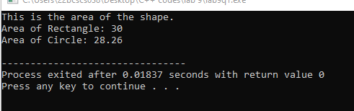

Q2)

#include <iostream>

using namespace std;

class MyClass {

private:

int value;

public:

MyClass(int v) {

value = v;

}

friend void displayValue(MyClass obj);

};

void displayValue(MyClass obj) {

cout << "The value is: " << obj.value << endl;

}

int main() {

MyClass obj(5);

displayValue(obj);

return 0;

}

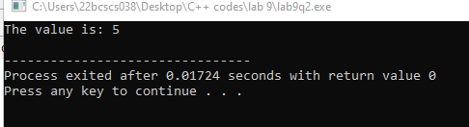

Q3)

//Array taken { 5, 2, 9, 1, 7}

#include <iostream>

using namespace std;

int\* findLargest(int\* arr, int size) {

int\* max = arr;

for (int i = 1; i < size; i++) {

if (arr[i] > \*max) {

max = &arr[i];

}

}

return max;

}

int\* findSmallest(int\* arr, int size) {

int\* min = arr;

for (int i = 1; i < size; i++) {

if (arr[i] < \*min) {

min = &arr[i];

}

}

return min;

}

int main() {

int arr[] = { 5, 2, 9, 1, 7 };

int size = sizeof(arr) / sizeof(arr[0]);

int\* largest = findLargest(arr, size);

int\* smallest = findSmallest(arr, size);

cout << "Largest element: " << \*largest << endl;

cout << "Smallest element: " << \*smallest << endl;

return 0;

}

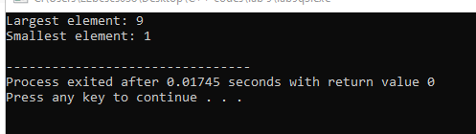

Q4)

//Array taken {1,2,3,4,5}

#include <iostream>

using namespace std;

void reverseArray(int\* arr, int size) {

int\* start = arr;

int\* end = arr + size - 1;

while (start < end) {

int temp = \*start;

\*start = \*end;

\*end = temp;

start++;

end--;

}

}

int main() {

int arr[] = { 1, 2, 3, 4, 5 };

int size = sizeof(arr) / sizeof(arr[0]);

reverseArray(arr, size);

cout << "Reversed array: ";

for (int i = 0; i < size; i++) {

cout << arr[i] << " ";

}

cout << endl;

return 0;

}

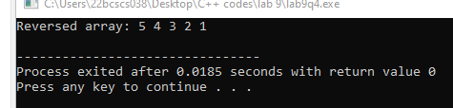

Q5)

#include <iostream>

using namespace std;

class Student {

private:

string name;

int age;

public:

Student(string n, int a) {

name = n;

age = a;

}

Student(const Student& other) {

name = other.name;

age = other.age;

}

void displayInfo() {

cout << "Name: " << name << ", Age: " << age << endl;

}

};

int main() {

Student s1("John", 20);

Student s2 = s1;

s1.displayInfo();

s2.displayInfo();

return 0;

}

